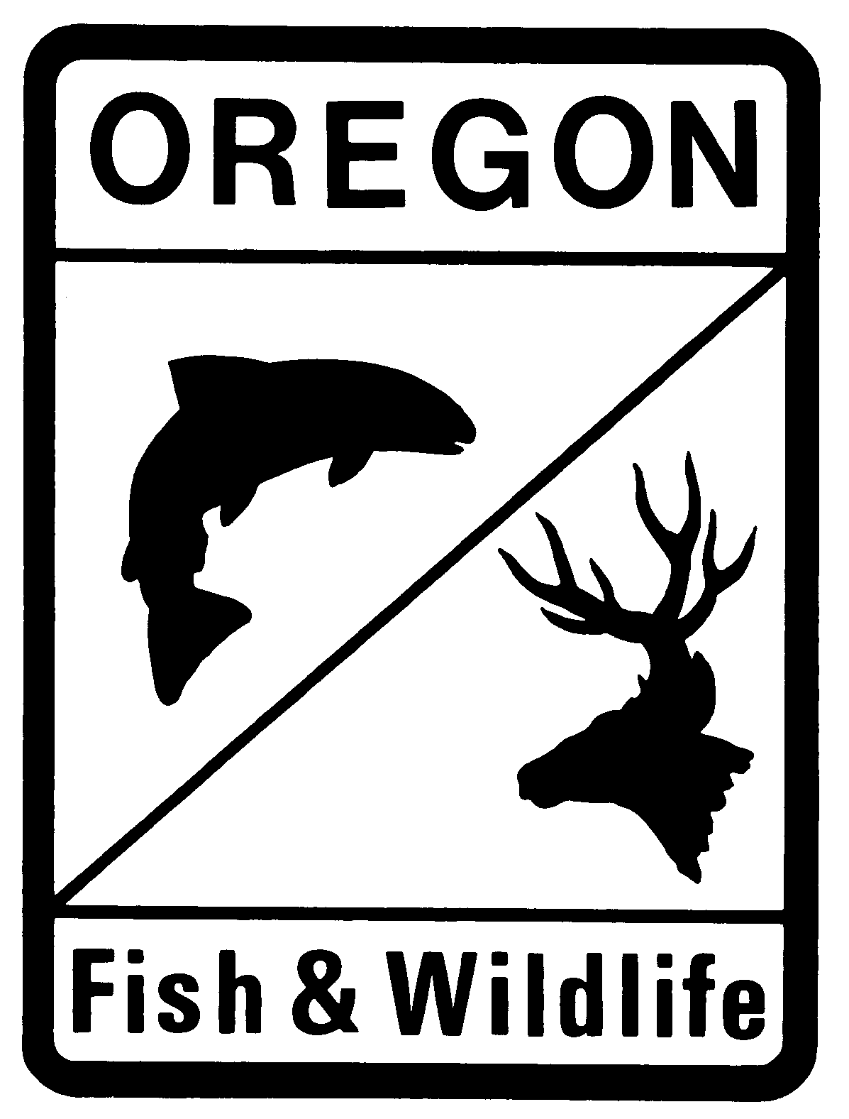
Oregon Department of Fish and Wildlife
Documentation of Criteria for Environmental Restoration Weirs (ERW)
Review of stream Qualifications

To be completed by project applicant:
Applicant Name: Date:
Contact information:
Stream Basin:

☐Harney-Malheur Lakes (HUC1712001)
☐Silvies (HUC 1712002)
☐Donner and Blitzen (HUC 1712003)
☐Silver (HUC 1712004)
☐Summer Lake (HUC 1712005)
☐Lake Abert (HUC 1712006)
☐Warner Lakes (HUC 1712007)
☐Guano (HUC 1712008)
☐Alvord Lake (HUC 1712009)

Stream Name:

Provide GPS coordinates of the proposed project reach.
Coordinates (NAD 83 in decimal degrees to at least 4 places):
Latitude: °N Longitude: °W

Has ODFW provided a determination of native migratory fish population health and fish/no fish determination?

Yes No
(If fish use is unknown contact ODFW to arrange sampling. Sampling must occur during the time of year when the stream is most likely to have fish.)

Review of stream Qualifications

Provide information documenting that the stream is incised or eroded by two feet or more relative to the ancient floodplain.
(May be accomplished through pictures, historic records, aerial images, and/or state wetlands map. ODFW suggests taking pictures during the low flow periods in July and August to most clearly show the conditions of the stream.)

Information may include attachments documenting the following criteria:
- Loss of natural wetlands, riparian, or meadow conditions on the adjacent surfaces.
- The absence of overbank flooding or deposition during ordinary periods of high streamflow and/or
- The presence of invasive dry land species that have encroached from adjacent uplands, including but not limited to sagebrush, bunch grass, juniper, and pine.

To be completed by Oregon Department of Fish and Wildlife:
ODFW Fish Determination

Name of biologist making the fish determination: _____________________________________
Are native migratory fish present at the project location?
If No: Reason for no-fish call:
Sampled no fish/downstream barrier
Sampled no fish/poor habitat
Not in historic fish distribution
Professional opinion
Other, explain:

In your professional opinion how likely are fish to return to the area:

If yes, please list the species and provide information on the fish population health:

